  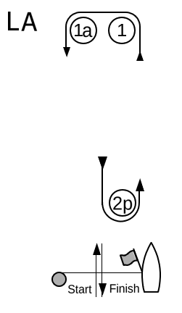
  Course LA – Windward/Leeward with Offset Mark, Leeward Finish
  Signal | Mark Rounding Order
  LA2 | Start – 1 – 1a – 2p – 1 – 1a – Finish
  LA3 | Start – 1 – 1a – 2p – 1 – 1a – 2p – 1 – 1a – Finish
  LA4 | Start – 1 – 1a – 2p – 1 – 1a – 2p – 1 – 1a –2p – 1 – 1a – Finish
  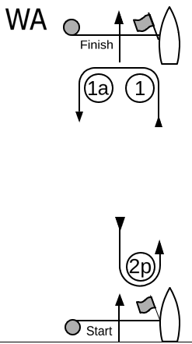
  Course WA – Windward/Leeward with Offset Mark, Windward Finish
  Signal | Mark Rounding Order
  WA2 | Start – 1 – 1a – 2p – Finish
  WA3 | Start – 1 – 1a – 2p – 1 – 1a – 2p – Finish
  WA4 | Start – 1 – 1a – 2p – 1 – 1a – 2p – 1 – 1a – 2p – Finish

