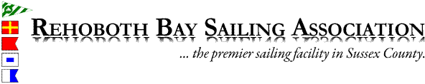
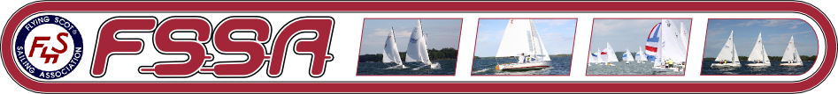

Notice of Race
2018 Capital District Flying Scot Regatta
August 17-19, 2018

Organizing Authority: Rehoboth Bay Sailing Association (RBSA), Flying Scot Fleet 206 and the Flying Scot Sailing Association (FSSA). Visit www.RBSA.ORG for more information about RBSA.
Rules: The regatta will be governed by the current edition of the Racing Rules of Sailing, except as altered by the Sailing Instructions or as posted on the Regatta Bulletin Board.
Eligibility: The regatta is open to all Active, Life, Junior, Club, and Family members of FSSA that meet the requirements per the FSSA Constitution, including Flying Scot ownership requirements. Current membership is required for all helmsmen.
Registration Fee: The Registration fee will be $90 per boat. (Fee includes meal Package: Continental breakfast Saturday and Sunday morning, Lunch on Saturday and Sunday, and Dinner Saturday night; each additional person is $20). The registration form with mailing instructions is attached and can be downloaded/printed from RBSA’s web site.

Schedule:
Friday Aug 17
12:00 Noon RBSA open for boat parking
1:00 pm Free clinic to be given by Zeke Horowitz from North Sails. Begins with brief ‘chalk talk’ followed by on water practice with on shore debrief at 5:00 pm. Great opportunity to fine tune your sailing skills!
Saturday Aug 18
8:30-10:00 Registration, Continental Breakfast
10:00 Skipper’s Meeting
10:30 Race Committee Departs for Racecourse
11:30 Warning Signal for Races 1 -3
After Races Appetizers, Dinner, and Party at RBSA
Sunday Aug 19
8:00 Continental Breakfast
10:00 Warning Signal for Races 4-5
*No race will start after 2:30 p.m.*
Awards to follow the last race of the day.

Racing Area and Courses: The race area shall be Rehoboth Bay. The courses to be sailed will be Windward-Leeward as described in the Sailing Instructions. Rehoboth Bay is a great sailing venue for smaller craft…reliable ocean breezes throughout the summer months, gentle currents, and sandy beaches.
Sailing Instructions: Sailing instructions will be available at registration. RBSA is equipped with a hoist for launching so please bring your lifting bridle, if you have one. Launching ramps are also located nearby as well. A representative from North Sails will also be holding a clinic on Friday, August 17 for any interested regatta participants.
Measurement: Boats and sails must conform to the Official Plan. Each boat must carry equipment required by FSSA By-Law Article S-V2 restrictions and US Coast Guard requirements.
Scoring: Scoring will be the low scoring system as defined in RRS Appendix A. A boat’s series score will be the total of her race scores; no score will be excluded. Five races are scheduled; however, one race is required to constitute a regatta.
Awards: Awards will be given to skipper and crew of the top 3 finishing teams.
Liability: Competitors participate in the regatta entirely at their own risk. See Rule 4, Decision to Race. The organizing authorities will not accept any liability for material damage or person injury or death sustained in conjunction with or prior to, during or after the regatta.
Camping: Campsites with RV hook ups are located just a few miles south of RBSA at the Indian River Marina located within the Delaware Seashore State Park; other camp sites are located at Cape Henlopen State Park. Visit www.destateparks.com/ for more information. RBSA grounds have ample room for RV’s/Camping Trailers but no hook ups. The club house is equipped with full restroom facilities including hot showers.
Hotels: There are numerous hotels nearby. Just do a Google search for hotels near Rehoboth Beach Delaware to check on rates and availability. You can also check for hotel/motels in the Fenwick Island, DE or Ocean City, MD which are a bit further but still within a 20 to 30 minute drive. This is a resort area so please try to book early.
Directions: RBSA is located on the coastal highway just south of Dewey Beach, Delaware. Physical address is: 38767 Rehoboth Bay Sailing Assoc. Lane. Dewey Beach, DE 19971 and can be located on Google Maps.
Contact Information: Don Walbrecht at (302) 569-1244 or (302) 537-1602; Roger Anderson at (302) 296-8879
2018 Capital District Flying Scot Regatta
August 17-19
Registration Form
(Please print or write legibly)

Skipper Name: _________________________________________________

Street Address: ________________________________________________

Town/State/Zip: ________________________________________________

Phone: __________________________ Email: ________________________

Crew Name (s): _________________________________________________

Emergency Contact Name and Phone: ________________________________

Sail #: ______________ Fleet # _______ Club Affiliation: _________________

Registration Fee $90.00 ______________ (Per boat and skipper)
Additional Meal Package $20.00 ______________ (per each additional person)
Total Due $_______________

Payment: Make checks payable to RBSA and note FSSA Regatta on memo section; OR by credit card:
I _____________________________authorize RBSA to Charge my Master Card, Discover, or Visa
(name as it appears on your card)
Account
Acct. No: ___________________________________________

Security Code: ____________ Expiration Date: ______________________

NOTE: Competitors participate in the regatta entirely at their own risk: The organizing Authority will not accept any liability for material damage, personal injury, or death sustained in connection with, prior to, during, or after the race clinic. I agree to abide by all rules and all other rules that govern this event

Signature: ____________________________________ Date: _____________________
Mail this form to: Parcel Plus
19266 Coastal Hwy
Unit 4
Rehoboth Beach, DE 19971
ATTN: FS CD Regatta

