MIDWINTERS -LET THE FUN BEGIN !!!
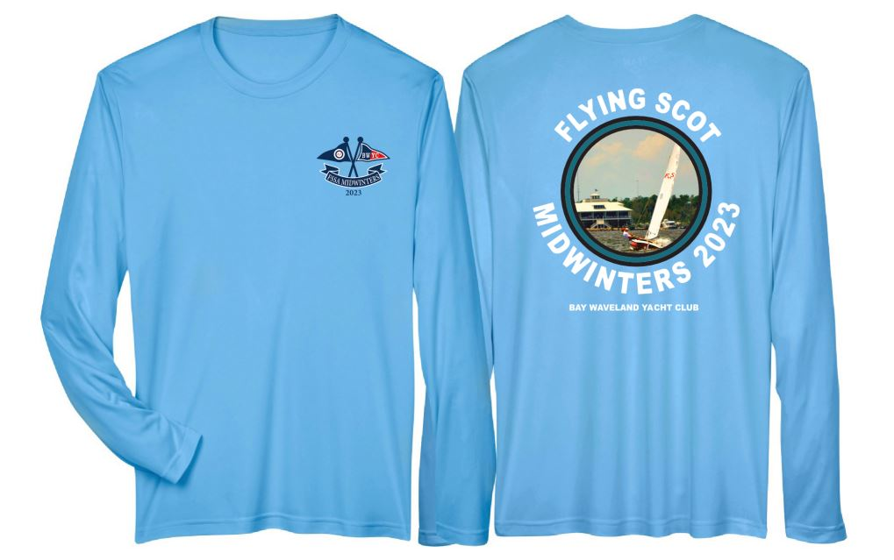

FS Midwinters shirts will be available for purchase in the clubhouse at BWYC.
The long sleeve performance shirt is moisture -wicking with a UV 40+ rating. Color is Light Blue.

There is also a 100% cotton long sleeve shirt available. It is also light blue and printed as the performance shirt.

Each shirt is $25.00 for S-XXL if preordered by February 20 and $30 at the desk of the club without preorder. Sales tax will be added at purchase. Preorder by emailing your size and which shirt you would like so that we can have sufficient quantities for you. mgtaylor.ms@gmail.com

At the registration desk, you can sign up for additional meal plans for $75 each for people in your group beyond the two covered by the registration fee. The meal plan includes the two evening meals and lunches Monday through Thursday.

