# fssa decal

Flying Scot Fleet 37 invites you to sail the

**2019 Buckeye Regatta**

**May 17- 19, 2018**

You are invited to enjoy a weekend of sailing at the 2019 Buckeye Regatta, hosted by Flying Scot Fleet 37 of Hoover Sailing Club. Races will be held on Hoover Reservoir, which is located in Westerville, Ohio, a northeastern suburb of Columbus. The regatta will include five races – three on Saturday and two on Sunday. Hoover Reservoir has a 10 HP limit, so water conditions are ideal.

**Registration**

$65 Postmarked by May 12th

$75 May 12th or later

To pre-register, please complete the enclosed form and mail to:

Dave Smith

1825 Hannah Farms Ct.

Blacklick, OH 43004

dave@os-homes.com

**Schedule**

**Friday, May 17**

6:30-10:00 pm HSC Gate Opens

7:00 pm Complimentary Finger Foods

and Drinks

**Saturday, May 18**

8:00 am HSC Gate Opens

8:30-10:00 am Registration & Complimentary

Continental Breakfast

11:30 am Lunch/Skippers Meeting

1:00 pm First, Second, and Third

Races (back to back)

6:00 pm Dinner

- Home Cooked

- Live Entertainment

- Open Bar

**Sunday, May 19**

8:00 am Complimentary Continental

Breakfast

9:30 am Fourth and Fifth Races

(no start after 11:30)

12:30 pm Lunch and Awards Presentation

**Accommodations**

Aloft, Westerville: (614) 866-6560

Renaissance, Westerville: (614) 882-6800

Hampton Inn & Suites Polaris: (614) 885-8400

Hilton Garden Inn: (800) 780-7234

Wingate Inn (800) 454-6835

Camping is permitted at Hoover Sailing Club.

Facilities include restrooms and showers.

HSC Members can accommodate sailors—call for details.



**Questions**

Stephanie Bahr

[stephhms5015@gmail.com](mailto:stephhms5015@gmail.com)

614-425-0725

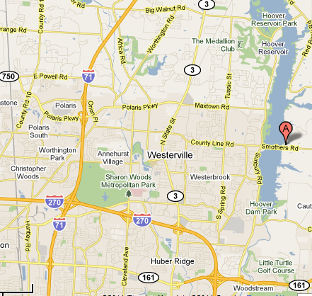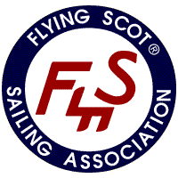

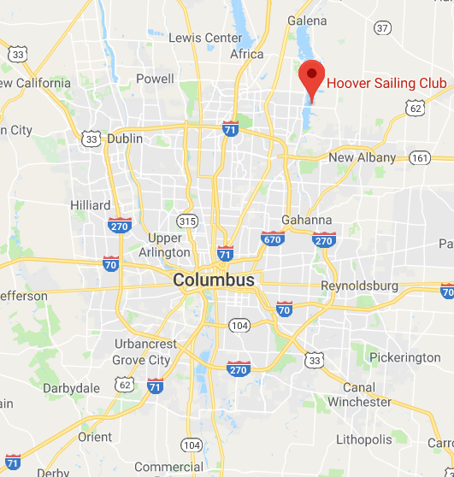

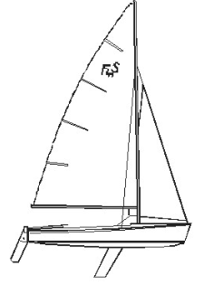

From I-270 take Route 161 east toward New Albany. Exit Route 161 at the next exit, Sunbury Road, and stay to the right to go north. Continue north on Sunbury until it intersects with County Line Road. (County Line Road is called Smothers Road east of Sunbury). Turn right onto Smothers Road, cross the bridge.

**Directions**

www.hooversailingclub.com

4250 Smothers Road, Westerville, Ohio